**NFS on the Server**

[[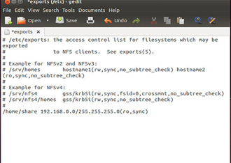](https://d37djvu3ytnwxt.cloudfront.net/assets/courseware/e4a7341747873bfe4ade5639f85991a6/asset-v1:LinuxFoundationX+LFS101x+1T2016+type@asset+block/LFS01_Ch08_screen10.jpg)](https://d37djvu3ytnwxt.cloudfront.net/assets/courseware/e4a7341747873bfe4ade5639f85991a6/asset-v1:LinuxFoundationX+LFS101x+1T2016+type@asset+block/LFS01_Ch08_screen10.jpg)We will now look in detail at how to use NFS on the server machine.

On the server machine, NFS daemons (built-in networking and service processes in Linux) and other system servers are typically started with the following command: sudo service nfs start

The text file /etc/exports contains the directories and permissions that a host is willing to share with other systems over NFS. An entry in this file may look like the following:

/projects *.example.com(rw)

This entry allows the directory /projects to be mounted using NFS with read and write (rw) permissions and shared with other hosts in the example.com domain. As we will detail in the next chapter, every file in Linux has 3 possible permissions: **read** (r), **write** (w) and **execute** (x).

After modifying the /etc/exports file, you can use the exportfs -av command to notify Linux about the directories you are allowing to be remotely mounted using NFS (restarting NFS with sudo service nfs restart will also work, but is heavier as it halts NFS for a short while before starting it up again).